SANSKAAR PATNI
180905134 CSE -C 23

CD-LAB 6

1.
S->a | > | ( T )
T->T, S|S

Removing left recursion
S-> a|>|(T)
T-> ST'
T'-> ,ST'|ε

No left factoring required

Code:
#include<stdio.h>
#include<stdlib.h>
int curr=0;
char str[100];

void S();
void T();
void Tprime();

void valid(){
printf("\n--SUCCESS--\n\n");
exit(0);
}

void invalid(){
printf("\n--ERROR--\n\n");
exit(0);
}

int main(){
printf("Enter string: ");
scanf("%s",str);
S();
if(str[curr]=='$')valid();
else invalid();
}

void S(){
if(str[curr]=='a')curr++;
else if(str[curr]=='>')curr++;
else if(str[curr]=='('){
curr++;
T();
if(str[curr]==')')curr++;
else invalid();
}
else invalid();
}
void T()
{
S();
Tprime();
}

void Tprime()
{
if(str[curr]==',')
{
curr++;
S();
Tprime();
}
}
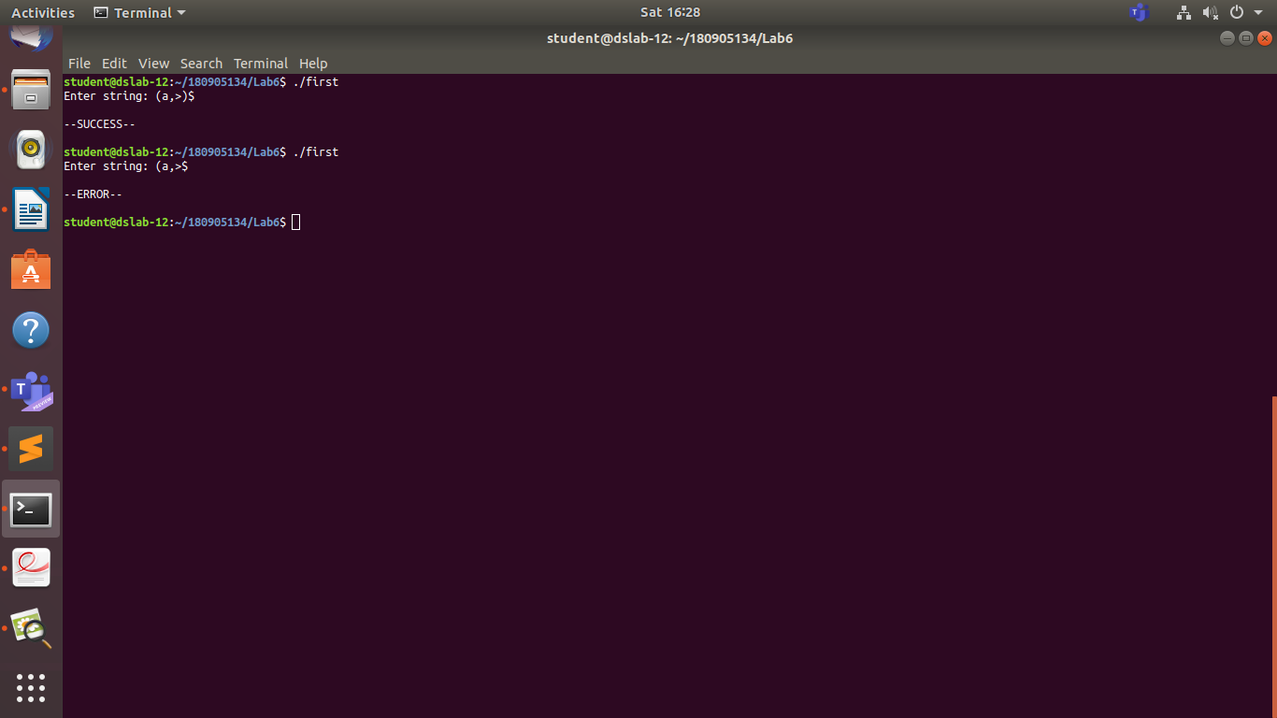

2.
S->UVW
U ->(S) | aSb | d

No left recursion
No left factoring required

Code:
#include<stdio.h>
#include<stdlib.h>

int curr=0;
char str[100];

void S();
void U();
void V();
void W();

void valid()
{
printf("\n----------SUCCESS!----------\n\n");
exit(0);
}

void invalid()
{
printf("\n----------ERROR!----------\n\n");
exit(0);
}

int main()
{
printf("Enter string: " );
scanf("%s",str);
S();
if(str[curr]=='$')
valid();
else
invalid();
}

void S()
{
U();
V();
W();
}

void U()
{
if(str[curr]=='(')
{
curr++;
S();
if(str[curr]==')')
{
curr++;
}
else
{
invalid();
}
}
else if(str[curr]=='a')
{
curr++;
S();
if(str[curr]=='b')
{
curr++;
}
else
{
invalid();
}
}
else if(str[curr]=='d')
{
curr++;
}
else
{
invalid();
}
}

void V()
{
if(str[curr]=='a')
{
curr++;
V();
}
}

void W()
{
if(str[curr]=='c')
{
curr++;
W();
}
}
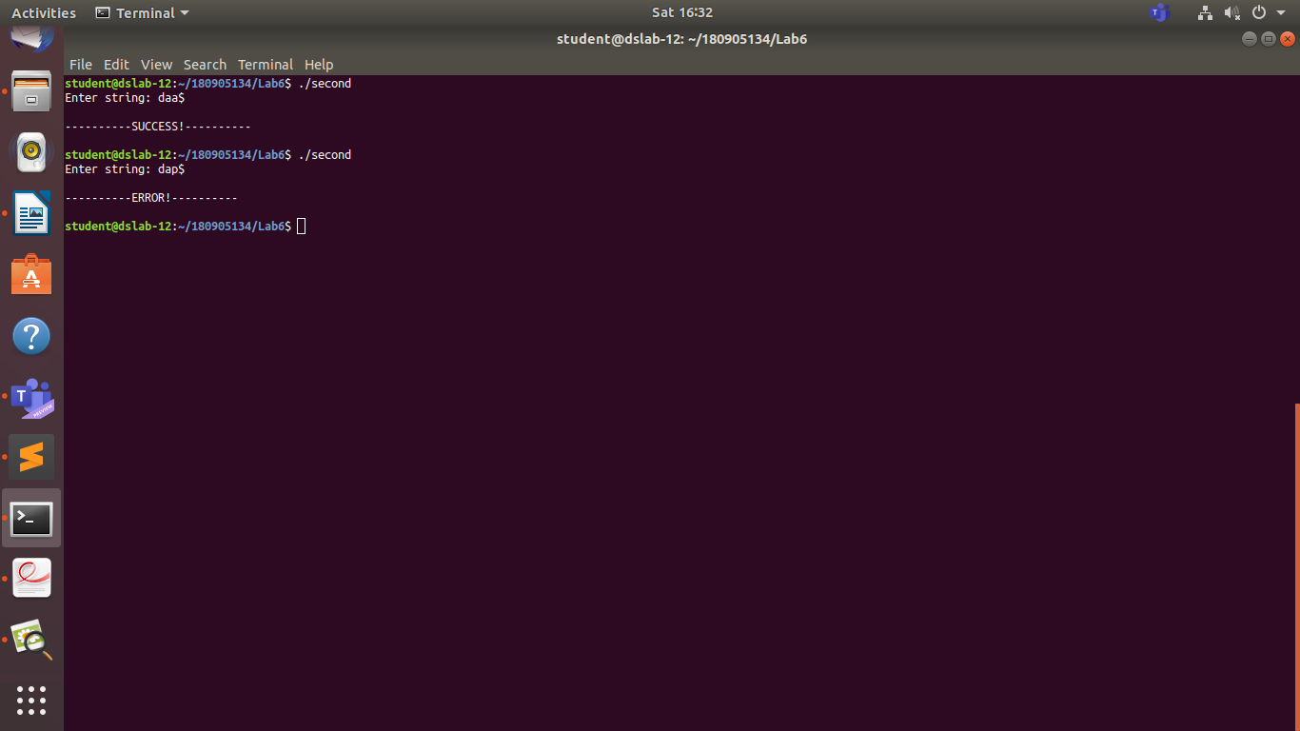

3.
S->aAcBe
A->Ab|b
B->d

Removing left recursion
S-> aAcBe
A-> bA'
A'-> bA'|ε
B-> d

No left factoring required

Code:
#include<stdio.h>
#include<stdlib.h>

int curr=0;
char str[100];

void S();
void A();
void Aprime();
void B();

void valid()
{
printf("\n----------SUCCESS!----------\n\n");
exit(0);
}

void invalid()
{
printf("\n----------ERROR!----------\n\n");
exit(0);
}

int main()
{
printf("Enter string: " );
scanf("%s",str);
S();
if(str[curr]=='$')
valid();
else
invalid();
}

void S()
{
if (str[curr]=='a')
{
curr++;
A();
if (str[curr]=='c')
{
curr++;
B();
if (str[curr]=='e')
{
curr++;
}
else
{
invalid();
}
}
}
else
{
invalid();
}
}

void A()
{
if (str[curr]=='b')
{
curr++;
Aprime();
}
else
{
invalid();
}
}

void Aprime()
{
if (str[curr]=='b')
{
curr++;
Aprime();
}
}

void B()
{
if (str[curr]=='d')
{
curr++;
}
else
{
invalid();
}
}
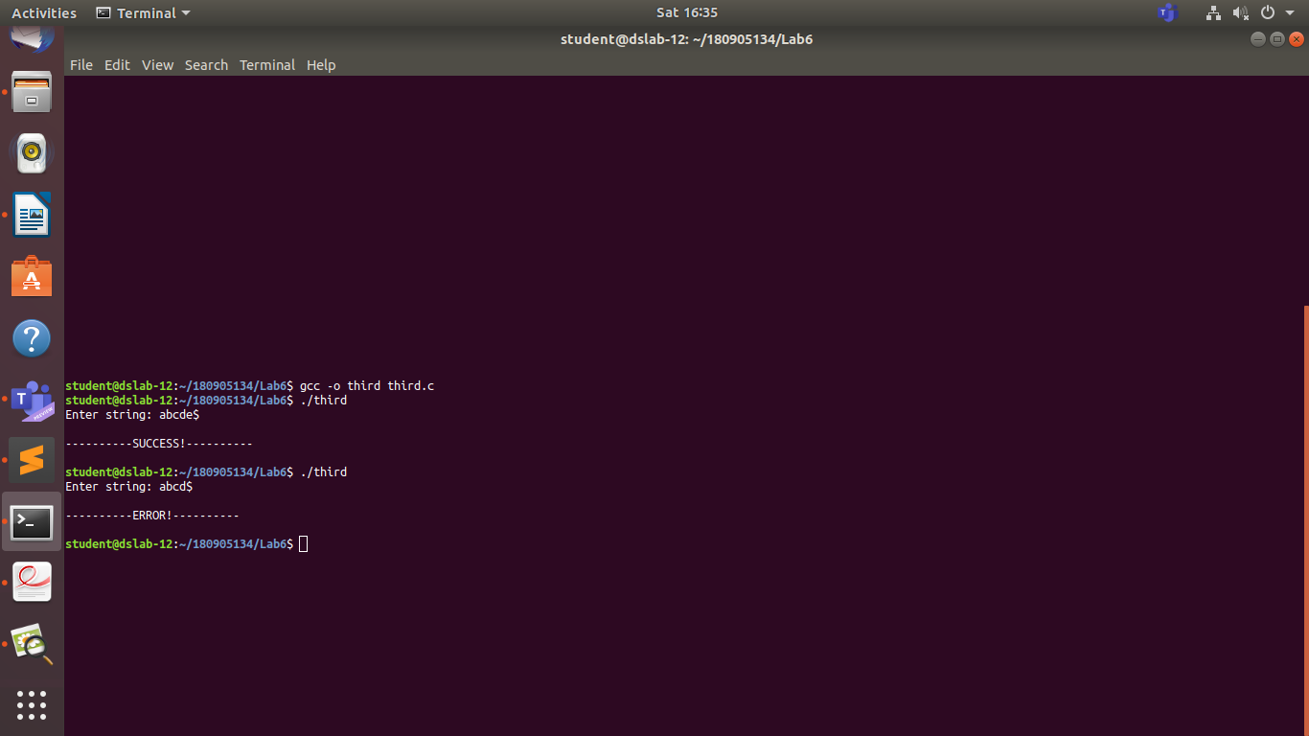

4.
S->(L) | a
L -> L,S | S

Removing left recursion
S-> (L)|a
L-> SL'
L'-> ,SL'|ε

No left factoring required

Code:
#include<stdio.h>
#include<stdlib.h>

int curr=0;
char str[100];

void S();
void L();
void Lprime();

void valid()
{
printf("\n----------SUCCESS!----------\n\n");
exit(0);
}

void invalid()
{
printf("\n----------ERROR!----------\n\n");
exit(0);
}

int main()
{
printf("Enter string: " );
scanf("%s",str);
S();
if(str[curr]=='$')
valid();
else
invalid();
}

void S()
{
if(str[curr]=='(')
{
curr++;
L();
if(str[curr]==')')
{
curr++;
}
else
{
invalid();
}
}
else if(str[curr]=='a')
{
curr++;
}
else
{
invalid();
}
}

void L()
{
S();
Lprime();
}

void Lprime()
{
if(str[curr]==',')
{
curr++;
S();
Lprime();
}
}
